With Max pooling in ViT
Stage 1: 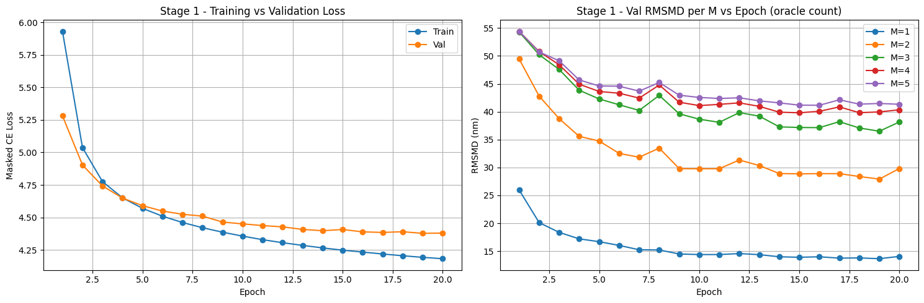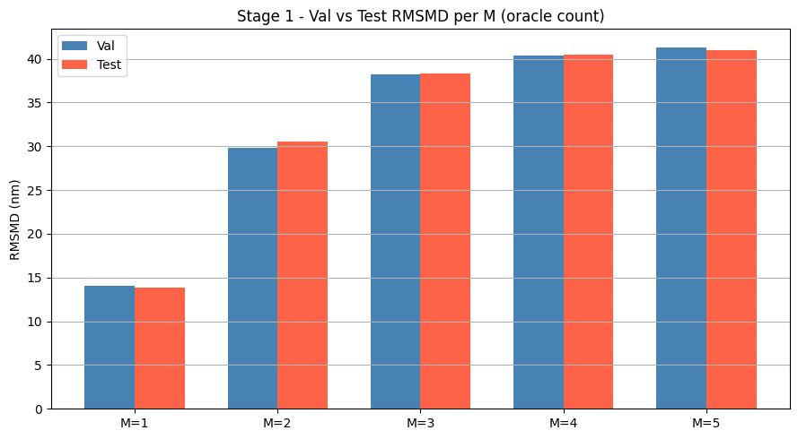Stage 2: loss = F.nll_loss(count_probs.clamp(min=1e-9).log(), M_counts)
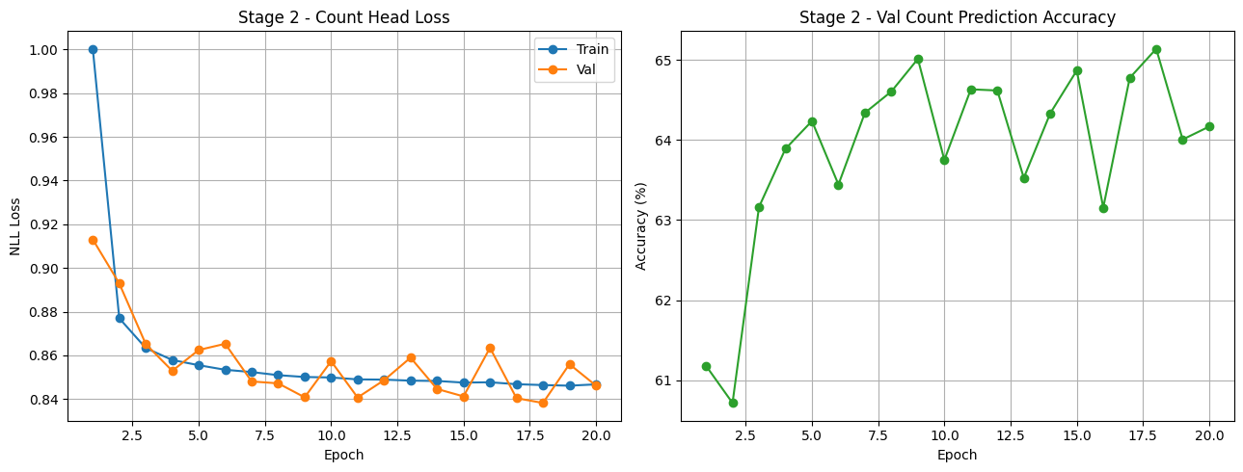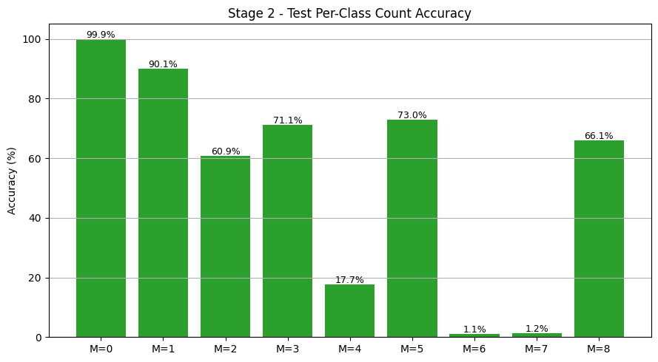
Stage 2:
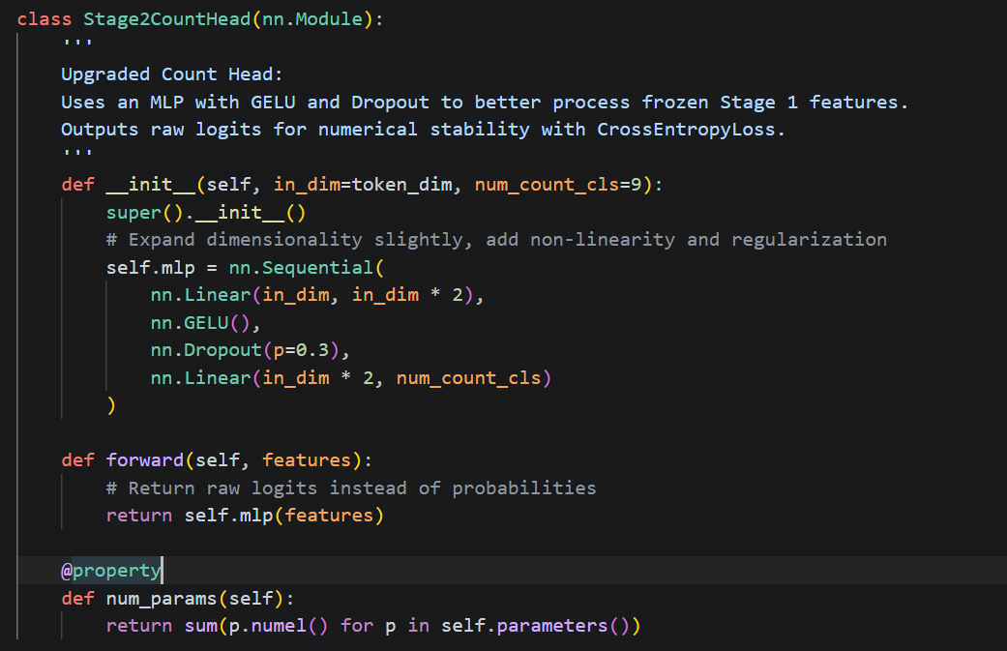
loss = F.cross_entropy(count_probs, M_counts)
With Average pooling in ViT
Stage1: 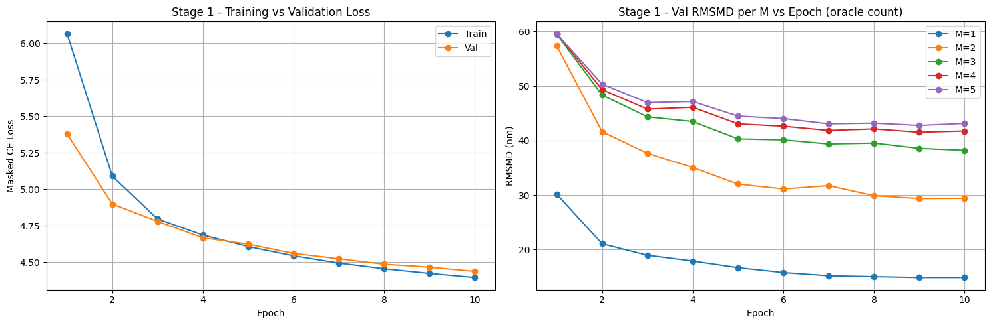 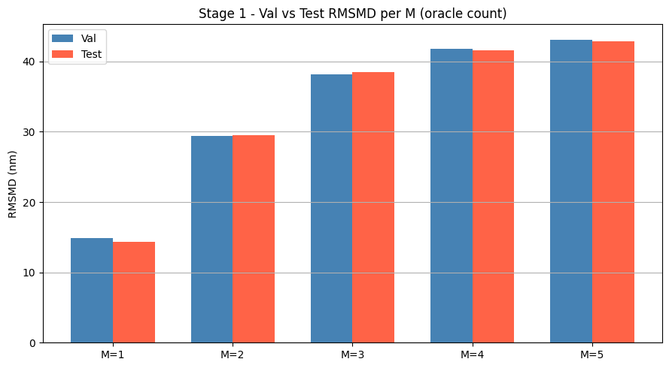
Stage 2: 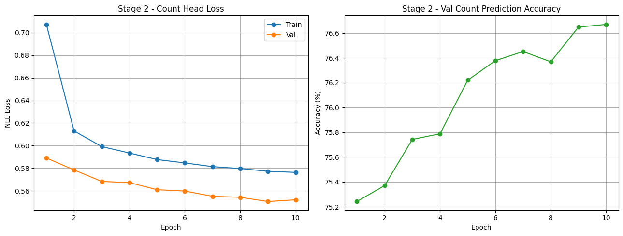 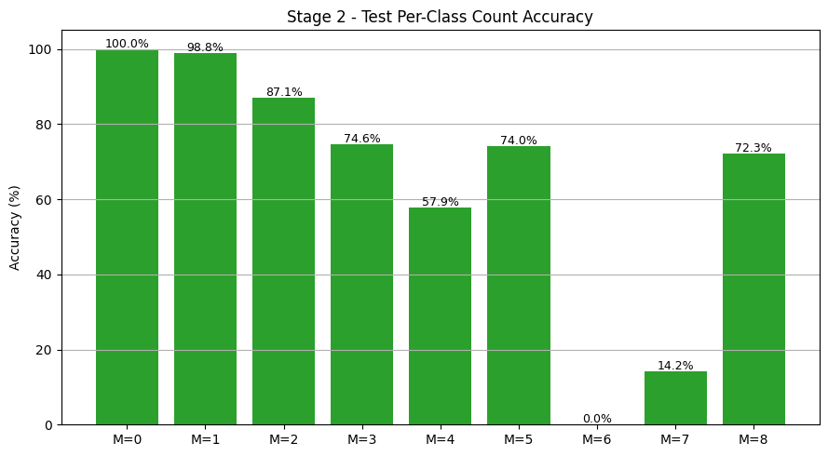
Mean pooling and add class weights.
# --- NEW Code Addition ---
class_weights = torch.tensor([1.0, 1.0, 1.0, 1.0, 1.0, 1.0, 4.5, 4.5, 4.5]).to(device)
criterion = nn.CrossEntropyLoss(weight=class_weights)


